Mid Tearm
Pdf - 01
1. What is Microprocessors?
Ans: Microprocessor is the core of computer systems. A microprocessor is a multipurpose, programmable, clock-driven, register based electronic device that reads binary instructions from a storage device called memory.
2. Why do we need to learn Microprocessors and Microcontrollers?
Today there is no electronic gadget on the earth which is designed without a Microcontroller. Ex: communication devices, digital entertainment, portable devices etc...
- Personal information products: Cell phone, pager, watch, pocket recorder, calculator.
- Laptop components: mouse, keyboard, modem, fax card, sound card, battery charger
- Home appliances: Door lock, alarm clock, air conditioner, Tv remote etc.
- Industrial equipment: Temperature/pressure controllers, Counters, timers, RPM Controllers
- Toys: video games, cars, dolls, etc.

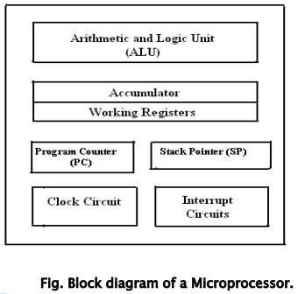
3. Explain Microprocessor with block diagram.
i. Arithmetic and Logic Unit (ALU) : It is the place where
actual computations take place. Consist of circuits which
performs arithmetic operations.

ii. Control Unit (CU): The coordination and control of a
computer is the sole responsibility of the Control Unit.

iii. Registers: Registers are temporary storage locations inside
microprocessor that holds data and address.

iv. Program counter (PC): It is commonly known as IP (Instruction
Pointer) in 8086, is a register in microprocessor that contains the
address of the next instruction to be executed.

v. Stack Pointer (SP): It is a small register that stores the address of
the last program/instruction request in a stack.

4. Microprocessor:
- CPU for Computers
- No RAM, ROM, I/O on CPU chip itself
- Example: Intel's x86, Motorola’s 680x0
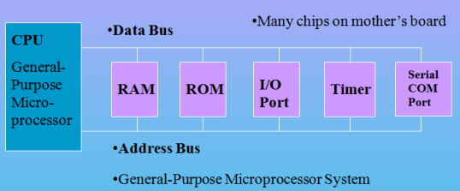

5. What is Microcontroller?
Ans: A microcontroller is a highly integrated single chip, which consists of on chip CPU (Central Processing
Unit), RAM (Random Access Memory), EPROM/PROM/ROM (Erasable Programmable Read Only Memory), I/O (input/output) – serial and parallel ports, timers, interrupt controller.
For example, Intel 8051 is 8-bit microcontroller and Intel 8096 is 16-bit microcontroller.
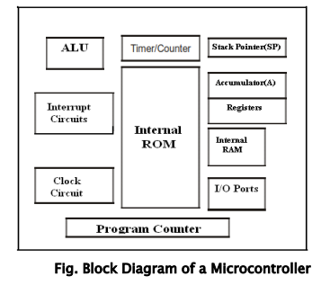
6. Block Diagram of Microcontroller:

7. Applications of Microcontrollers:
Cell phone, Pager, watch, calculator, video games, Alarm clock, air conditioner, Tv remote, Microwave oven, washing machines, robotic system, anti-lock braking system monitor.
8. Microcontroller:
- A smaller computer
- On-chip RAM, ROM, I/O ports...
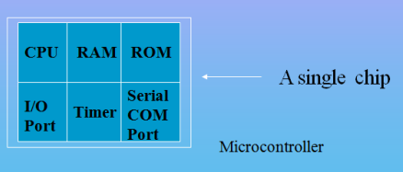
- Example: Motorola’s 6811, Intel’s 8051, Zi log’s Z8 and PIC

9. What is RISC (Reduced Instruction Set Computer)?
It stands for Reduced Instruction Set Computer. It is a type of microprocessor architecture that uses a small set of instructions of uniform length. These are simple instructions that are generally executed in one clock cycle. RISC chips are relatively simple to design and inexpensive. Examples: SPARC, POWER PC etc.
10. What is CISC (Complex Instruction Set Computer)?
It stands for Complex Instruction Set Computer. These processors offer the users, hundreds of instructions of variable sizes. CISC architecture includes a complete set of special-purpose circuits that carry out these instructions at a very high speed. CISC processors reduce the program size and hence lesser number of memory cycles are required to execute the programs. This increases the overall speed of execution.
Examples: Intel architecture, AMD
11. Distinguish with Microprocessor and Microcontroller.
Microprocessor | Microcontroller
CPU is stand-alone, RAM, ROM, I/O, timer is separate | CPU, RAM, ROM, I/O and timer are all on a single chip
General-purpose | Single-purpose (control-oriented)
Designer can decide on the amount of ROM, RAM and I/O ports. | Fixed amount of on-chip ROM, RAM, I/O ports
High processing power | Low processing power
Typically, 16/32/64 – bit | Typically, 8/16 bit
Typically, deep pipeline (5-20 stages) | Typically, single-cycle/two-stage pipeline

12. Distinguish with RISC and CISC.
RISC | CISC
RISC stands for Reduced Instruction Set Computer. It’s focus on software. | CISC stands for Complex Instruction Set Computer. It’s focus on Hardware.
Uses only Hardwired control unit. | Uses both hardwired and microprogrammed control unit.
Can perform only Register to Register Arithmetic operations | Can perform REG to REG or REG to MEM or MEM to MEM
RISC is Reduced Instruction Cycle. | CISC is Complex Instruction Cycle.
Simple and limited addressing modes. | Complex and more addressing modes.
Code size is large | Code size is small
Here, addressing modes are less. | Here, addressing modes are more.

Pdf – 02

